DevOps and Testing
# Source: AI Source: Provided by: [Data Path: Persons Table -> ID Column: 1, Name_En Column: Motasem Essam] -> From: [Chatgpt (GPT‑5 Mini)] on [8/22/2025]
DevOps and Testing are closely connected — DevOps isn’t just about automating deployments, it’s also about integrating testing into every stage of the software delivery pipeline so quality is built in from the start.

1. What is DevOps in this context?
# Source: AI Source: Provided by: [Data Path: Persons Table -> ID Column: 1, Name_En Column: Motasem Essam] -> From: [Chatgpt (GPT‑5 Mini)] on [8/22/2025]
- DevOps = A culture and set of practices that bring development and operations together to deliver software faster, more reliably, and with continuous feedback.
- It uses automation, collaboration, and continuous integration/continuous delivery (CI/CD) to achieve this.
- In DevOps, testing isn’t a separate phase — it’s an ongoing activity embedded in the pipeline.

2. Role of Testing in DevOps
# Source: AI Source: Provided by: [Data Path: Persons Table -> ID Column: 1, Name_En Column: Motasem Essam] -> From: [Chatgpt (GPT‑5 Mini)] on [8/22/2025]
In DevOps, testing is:
- Continuous – Happens throughout the lifecycle, not just before release.
- Automated – So tests run quickly and consistently after every change.
- Integrated – Built into the CI/CD pipeline so no build gets deployed without passing required tests.

3. Types of Testing in DevOps Pipelines
# Source: AI Source: Provided by: [Data Path: Persons Table -> ID Column: 1, Name_En Column: Motasem Essam] -> From: [Chatgpt (GPT‑5 Mini)] on [8/22/2025]
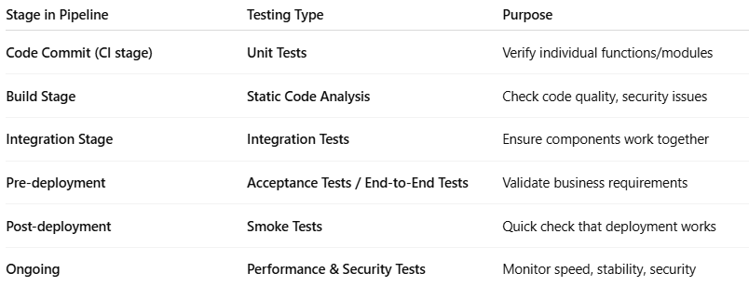
Stage in Pipeline | Testing Type | Purpose
Code Commit (CI stage) | Unit Tests | Verify individual functions/modules
Build Stage | Static Code Analysis | Check code quality, security issues
Integration Stage | Integration Tests | Ensure components work together
Pre-deployment | Acceptance Tests / End-to-End Tests | Validate business requirements
Post-deployment | Smoke Tests | Quick check that deployment works
Ongoing | Performance & Security Tests | Monitor speed, stability, security

4. Benefits of Testing in DevOps
# Source: AI Source: Provided by: [Data Path: Persons Table -> ID Column: 1, Name_En Column: Motasem Essam] -> From: [Chatgpt (GPT‑5 Mini)] on [8/22/2025]
- Early bug detection → cheaper to fix issues when found early.
- Faster feedback loop → developers know within minutes if they broke something.
- Higher confidence in releases → deployments are less risky.
- Better collaboration → QA, Dev, and Ops share responsibility for quality.

5. Example – Testing in a DevOps CI/CD Pipeline
# Source: AI Source: Provided by: [Data Path: Persons Table -> ID Column: 1, Name_En Column: Motasem Essam] -> From: [Chatgpt (GPT‑5 Mini)] on [8/22/2025]
- Developer pushes code → triggers pipeline.
- Pipeline runs:
  - Unit tests
  - Static code analysis
  - Integration tests
  - Acceptance tests
- If all pass → automatic deployment to staging or production.
- After deployment → smoke tests + monitoring.

💡 Key Point: In DevOps, testing shifts left — it moves earlier in the process and becomes everyone’s responsibility, not just QA’s.

